**Lesson 16 – Favorite Movie & Book**

**Warm-Up:** Describe your favorite movie and/or book. Why do you like it so much?

**Activity 1 – Pre-Learn Vocabulary**

**bride (n.)** = when a woman is getting married, she is called the “bride” on her wedding day. (and the man is called the “groom”)

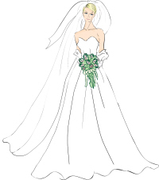

**farmhand (n.)** = a person who is employed to work on a farm.

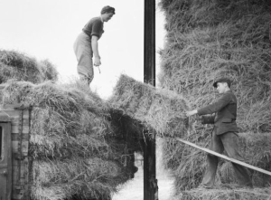

**fencing (n.)** = a type of sport in which the competitors fight with long, thin swords:

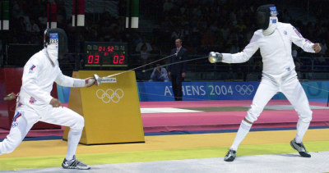

**pirate (n.)** = a bandit who robs ships on the ocean:

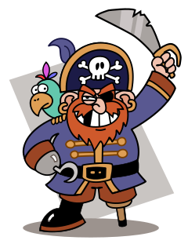

**witch (n.)** = a woman who does magic, using spells, potions, etc. The male equivalent is a **wizard.**

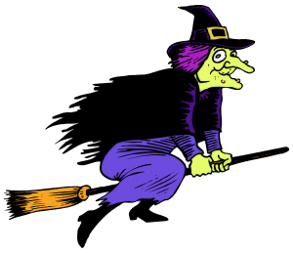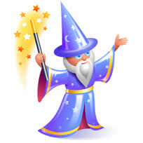

**villain (n.)** = the “bad” character in the story, who is usually the enemy of the hero

**satire (n.)** = a story that is based on another story (or on real events), but which changes things and uses irony, sarcasm, or ridicule to be humorous or to make a thought-provoking point

**Activity 2 – Listen for the General Idea**

***Speakers: Dan, Ashley - Australian***

1. **Dan’s favorite movie can be described as...**
2. a fantasy adventure story
3. a historical fiction film
4. a romantic comedy
5. **Ashley's favorite book can be described as...**
6. an action-packed thriller with lots of suspense
7. a background story for a classic character
8. an inspirational real-life story

**Activity 3 – Listen for Specific Details**

***True or False?***

1. Dan’s favorite movie came out in 1997.
2. There is a love story in the movie.
3. The movie is too violent for children.
4. The movie is very serious.
5. Dan memorized the entire movie.
6. Dan’s favorite part is a chase scene.
7. The movie inspired Dan to make his own films.
8. Ashley's favorite book was written in 1995.
9. The book makes you hate the Wicked Witch even more.
10. The book was also turned into a movie.

**Activity 4 – Listen for Specific Words**

**DAN**

Hi, my name is Dan and I wanted to take a moment to tell you about one of my favorite movies of all time. It is called, "The Princess Bride." This movie came out in 1987 and I was still a young boy - so I think that is the main Click here to enter text. why I am so fond of it.

The story revolves around a girl named Buttercup and her farmhand named Wesley. They fall in love, but there comes a time when Wesley decides to Click here to enter text. to seek his fortune. While he is gone, Buttercup is captured by an evil prince, and the story follows their fantastic journey through a fantasy land as they try to Click here to enter text. the evil prince and reunite.

This movie has everything. To quote a line from the movie, "This story has fencing, fighting, torture, revenge, chases, escapes, Click here to enter text. love, miracles..." It has everything for everybody. It's a great family movie, it's a great movie for men and women alike. It takes itself seriously, but it also takes time to make Click here to enter text. and have fun with itself.

I watched this movie as a kid all the time - so much so that I memorized every single Click here to enter text. of dialogue in the film. And if I watched it today, I would probably discover that I still do have it memorized.

One of the characters in the movie is a pirate, and there is a scene where he fences with another guy. And that is probably the most Click here to enter text. part of the film for me. As a young boy I loved this character so much I even dressed up as him for Halloween, and I just loved fencing and sword Click here to enter text..

I don't want to give away too much, if you haven't seen it - even though I know the film came out 30 years ago - but I really really love this movie so much and I would say that this movie was in part Click here to enter text. for my love of making my own movies. It inspired my Click here to enter text., my ability to dream up new stories and fantasy, and I love making my own stories today - even with my young four boys, we make Click here to enter text. little films.

This is a movie that I plan to show them when they are old enough and I hope you get a Click here to enter text. to watch it too.

**ASHLEY**

Hello, my name is Ashley and today I'm going to talk to you about my favorite book. My favorite book is titled *Wicked: The Life and Times of the Wicked Witch of the West,* and it was written by Gregory Maguire in 1995 and this book Click here to enter text. on the background story of the Wicked Witch of the West. So it focuses on her family life and how she grew up and the Click here to enter text. leading up to her being the Wicked Witch of the West that you see in the Wizard of Oz. So it really focuses on her before the whole Dorothy story came into play.

And the reason why I really like this is because it gives one of those Click here to enter text. villains, it gives you their background story - so rather than, you know, kind of being like "oh she's a villain, I really don't like her," you read this story and you're like "OK, now I Click here to enter text. why she became who she became, and I actually really like this character and I kind of feel Click here to enter text. for her."

This book is also a famous Broadway play titled "Wicked," and I myself have not seen it on Broadway but I'm hoping that Click here to enter text. I can make it out to New York - hopefully it's still playing - so I can see it on Broadway. I really suggest this book if you like kind of those satires or getting background stories from your Click here to enter text. movies and books - so yeah, *Wicked: The Life and Times of the Wicked Witch of the West* by Gregory Maguire - check it out!

**Complete Transcript**

**DAN**

Hi, my name is Dan and I wanted to take a moment to tell you about one of my favorite movies of all time. It is called, "The Princess Bride." This movie came out in 1987 and I was still a young boy - so I think that is the main **reason** why I am so fond of it.

The story revolves around a girl named Buttercup and her farmhand named Wesley. They fall in love, but there comes a time when Wesley decides to **leave** to seek his fortune. While he is gone, Buttercup is captured by an evil prince, and the story follows their fantastic journey through a fantasy land as they try to **escape** the evil prince and reunite.

This movie has everything. To quote a line from the movie, "This story has fencing, fighting, torture, revenge, chases, escapes, **true** love, miracles..." It has everything for everybody. It's a great family movie, it's a great movie for men and women alike. It takes itself seriously, but it also takes time to make **jokes** and have fun with itself.

I watched this movie as a kid all the time - so much so that I memorized every single **line** of dialogue in the film. And if I watched it today, I would probably discover that I still do have it memorized.

One of the characters in the movie is a pirate, and there is a scene where he fences with another guy. And that is probably the most **memorable** part of the film for me. As a young boy I loved this character so much I even dressed up as him for Halloween, and I just loved fencing and sword **fighting**.

I don't want to give away too much, if you haven't seen it - even though I know the film came out 30 years ago - but I really really love this movie so much and I would say that this movie was in part **responsible** for my love of making my own movies. It inspired my **imagination**, my ability to dream up new stories and fantasy, and I love making my own stories today - even with my young four boys, we make **short** little films.

This is a movie that I plan to show them when they are old enough and I hope you get a **chance** to watch it too.

**ASHLEY**

Hello, my name is Ashley and today I'm going to talk to you about my favorite book. My favorite book is titled *Wicked: The Life and Times of the Wicked Witch of the West,* and it was written by Gregory Maguire in 1995 and this book **focuses** on the background story of the Wicked Witch of the West. So it focuses on her family life and how she grew up and the **events** leading up to her being the Wicked Witch of the West that you see in the Wizard of Oz. So it really focuses on her before the whole Dorothy story came into play.

And the reason why I really like this is because it gives one of those **evil** villains, it gives you their background story - so rather than, you know, kind of being like "oh she's a villain, I really don't like her," you read this story and you're like "OK, now I **understand** why she became who she became, and I actually really like this character and I kind of feel **bad** for her."

This book is also a famous Broadway play titled "Wicked," and I myself have not seen it on Broadway but I'm hoping that **someday** I can make it out to New York - hopefully it's still playing - so I can see it on Broadway. I really suggest this book if you like kind of those satires or getting background stories from your **classic** movies and books - so yeah, *Wicked: The Life and Times of the Wicked Witch of the West* by Gregory Maguire - check it out!

**Extra Vocabulary**

"This movie **came out** in 1987"

*We often use the phrasal verb “come out” when talking about the date, season, or year that a movie is released to the public.*

"Wesley decides to leave to **seek his fortune**"

*This expression means “to try to become rich and successful.”*

"To **quote** a line from the movie"

*To “quote” means you are repeating something someone said exactly.*

"I don't want to **give away** too much"

*In this context, the phrasal verb “give away” means “reveal secret information.”*

**This is a free sample lesson from the Listening Course.**

**You can register to get the complete course, with 45 lessons!**

[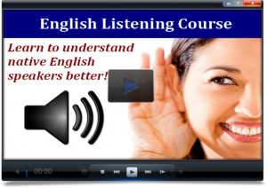](http://www.espressoenglish.net/do-you-want-to-improve-your-english-listening/)

[](http://www.espressoenglish.net/checkout-now/?rid=p9cw0n)

**Activity 2 Answers:**

1. a
2. b

**Activity 3 Answers:**

1. False
2. True
3. False
4. False
5. True
6. False
7. True
8. True
9. False
10. False